{{DATE}}

**{{CLIENT_NAME}}**

**{{ADDRESS}}**

**ATTENTION: {{CONTACT_PERSON}}**

Dear Sir/Madam,  
  
We take special pleasure in submitting our firm quotation for the KYOCERA DIGITAL COPIER TASKalfa 2554ci as follows:

**A3/SRA3 - FULL-COLOR MACHINE (BLACK AND COLORED PRINT/COPY/SCAN)**

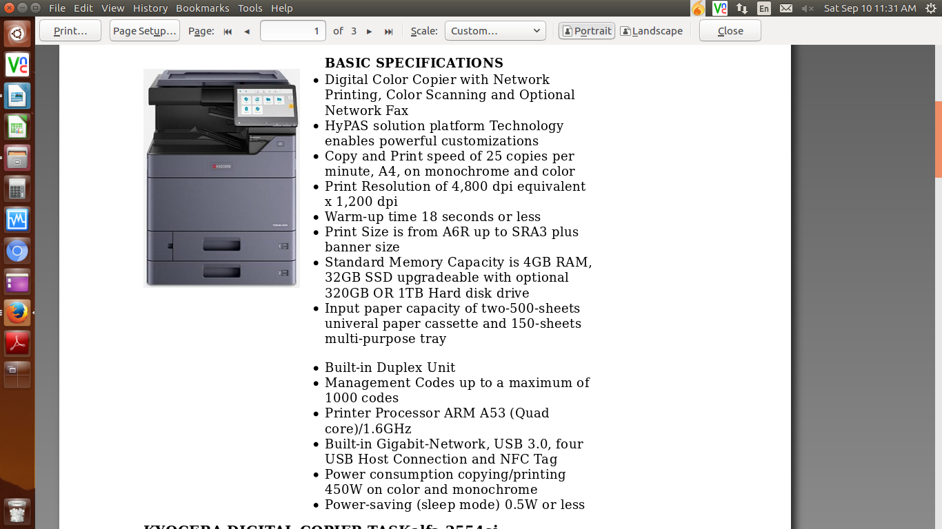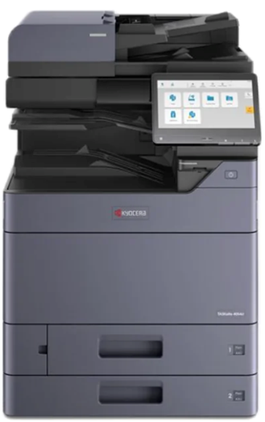

* **PRICE OF MACHINE & ACCESSORIES**

|  |  |  |
| --- | --- | --- |
| 1 unit of KYOCERA DIGITAL COPIER TASKalfa 2554ci | Php | **280,800.00** |

**PROMO**

MACHINE ORIGINAL PRICE Php 280,800.00

LESS PROMO DISCOUNT Php 36,000.00

================================================================================

TOTAL DISCOUNTED PRICE PHP 244,800.00 (LESS 15% IN COD = 208,080.00)

**===========================================================================**

**PHP 20,400/MO. FOR 12 MOS. (CREDIT CARD)**

**OPTIONAL/ACCESSORIES (NOT INCLUDED IN THE QUOTED PRICE)**

DOCUMENT PROCESSOR (AUTO-FEEDER) Php 49,500.00 (LESS 10% IN COD)

WIFI DIRECT/WIRELESS LAN Php 8,000.00 (LESS 10% IN COD)

STEEL TABLE/CABINET/PEDESTAL Php 6,200.00

LIFETIME SERVICE WARRANTY Php 14,400.00

ADDITIONAL PAPER CASSETTE (TWO 500-SHEETS) Php 98,600.00 (LESS 10% IN COD)

DOCUMENT FINISHER Php 258,000.00 (LESS 10% IN COD)

* **PRICE OF CONSUMABLES**

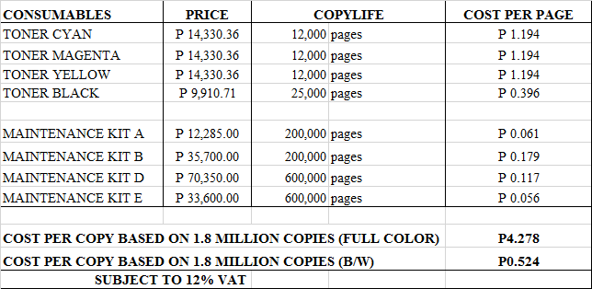

**Terms of Payment:** COD CASH/CHEQUE/12 MONTHS CREDIT CARD  
  
**VALIDITY:** Prices are subject to change without prior notice, please confirm with us prior to the finalization of the order.

**WARRANTY:**  
  
KYOCERA DIGITAL COPIER TASKalfa 2554ci is guaranteed spare parts replacement free of charge for TWO (2) YEARS or up to 600,000 copies/print/scan, whichever comes first. Warranty for options and accessories is valid for ONE (1) YEAR from the date of delivery.  
  
We also assure prompt service whenever you need assistance. Repair service is FREE for TWO (2) years. Should our machine require prolonged service, we shall install a backup unit immediately for your convenience.  
  
Important Guidelines: To ensure that our MFP meets the high standards of our customer’s quality expectations and functions according to its warranty life, please adhere to the guidelines below:

1. min. monthly output: 4,000 copies/max monthly output: 100,000 copies  
2. minimum color usage rate: 1,200 copies  
3. temperature:16 C to 27 C  
4. humidity: 36% -65%  
5. paper quality: thickness should be at least 80gsm, white, smooth, and dry  
6. paper quality: white, smooth & even surface, non-fibrous, least dusting, and non-moisture absorbent  
  
Special paper such as Transparency, adhesive-backed label paper, envelopes, colored paper, pre-printed paper, recycled paper, postcards, bond paper, and vellum can be used when it is under the correct specifications. For special papers not listed here, try testing it first with the MFP to ensure that the quality is satisfactory.  
  
Do not use the following paper type: coated or surface-treated paper, paper with plastic or carbon fibers, glossy paper, and perforated paper.

Moreover, the amount quoted above excludes the cost of any required tests or medical certifications such as, but not limited to Rapid tests, Antigen tests, and RT-PCR tests. The actual cost will be billed separately  
We are looking forward to hearing from you soon and serve your needs. For any questions or concerns, please do not hesitate to call us at 7618-0274. LET THE COLOR WORK FOR YOU.  
  
Thank you and have a good day!  
  
Very truly yours, Conforme:

**JAYPEE V. SONIEL __________________________________**  
SENIOR ACCOUNT EXECUTIVE II

09176240820 (Viber Ready)